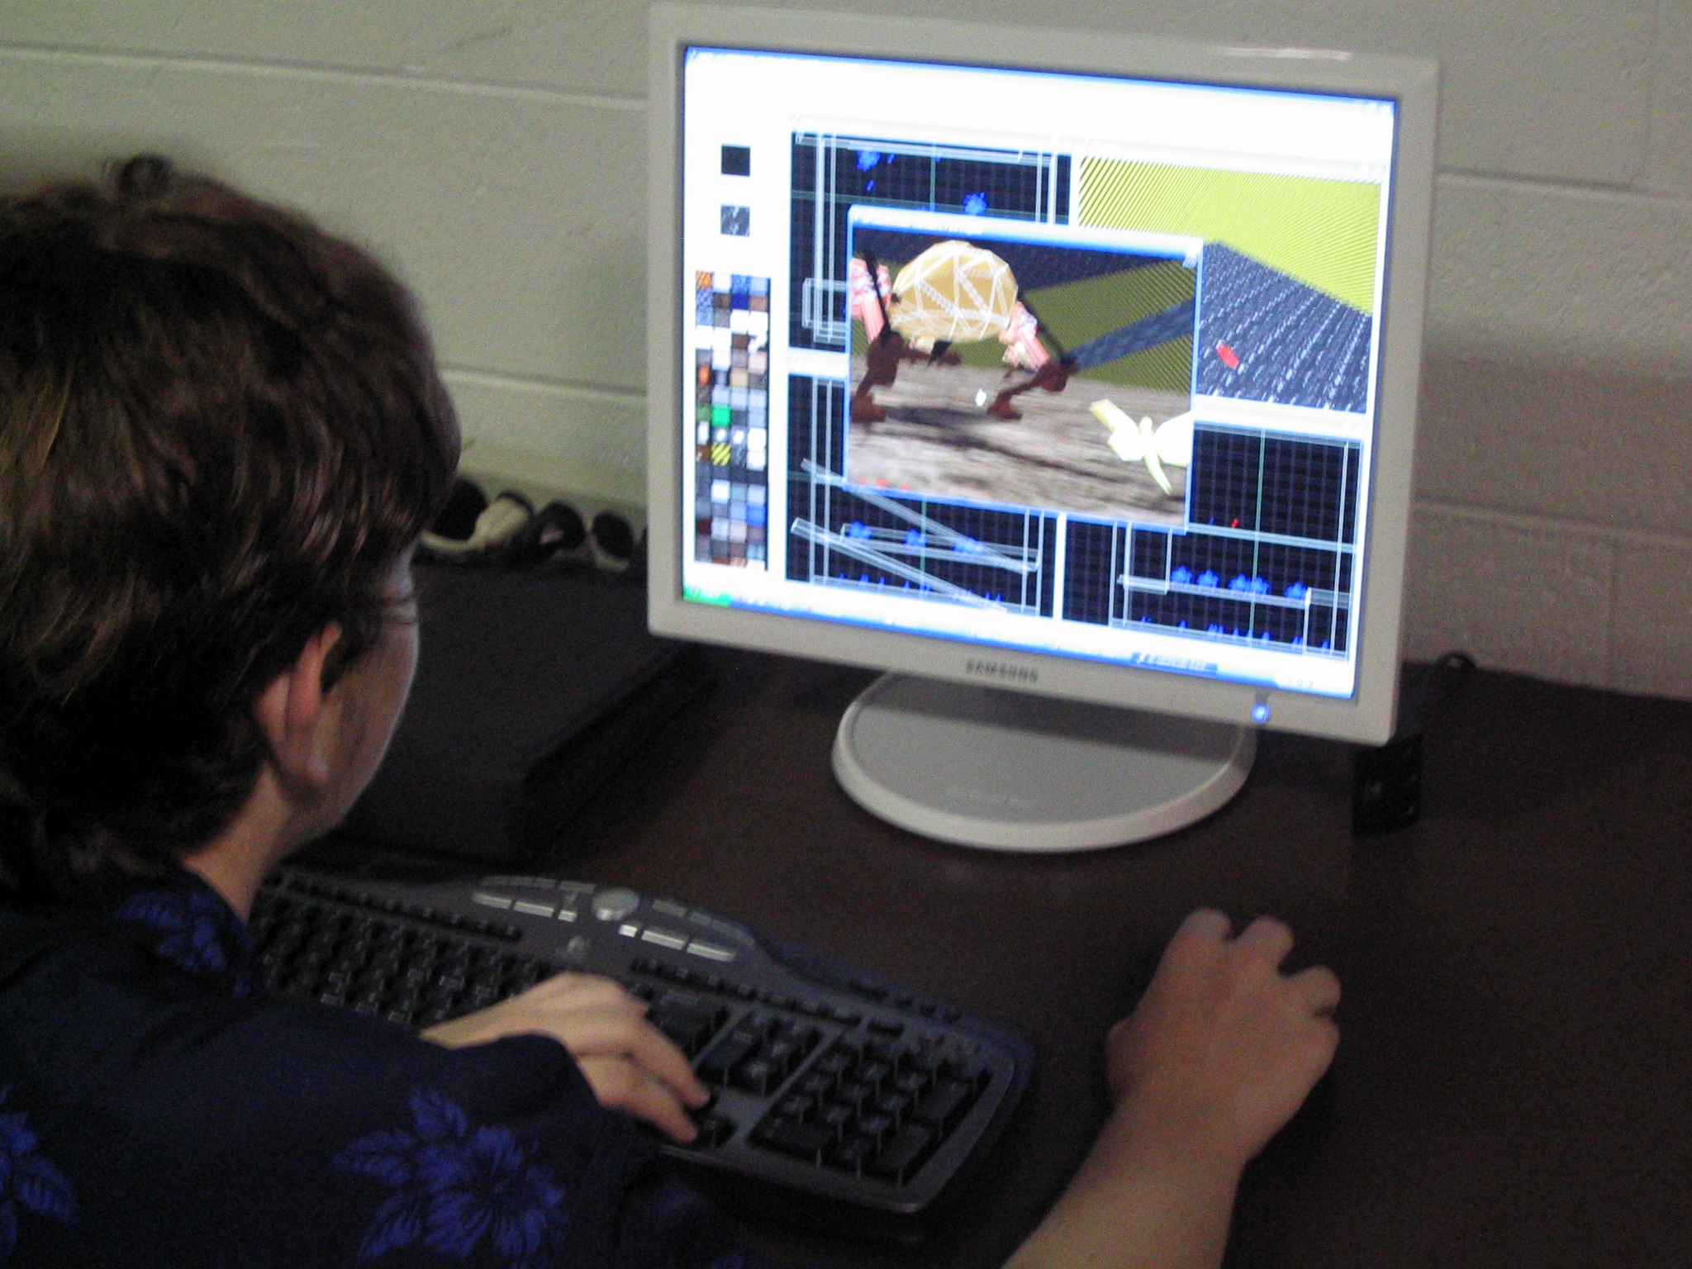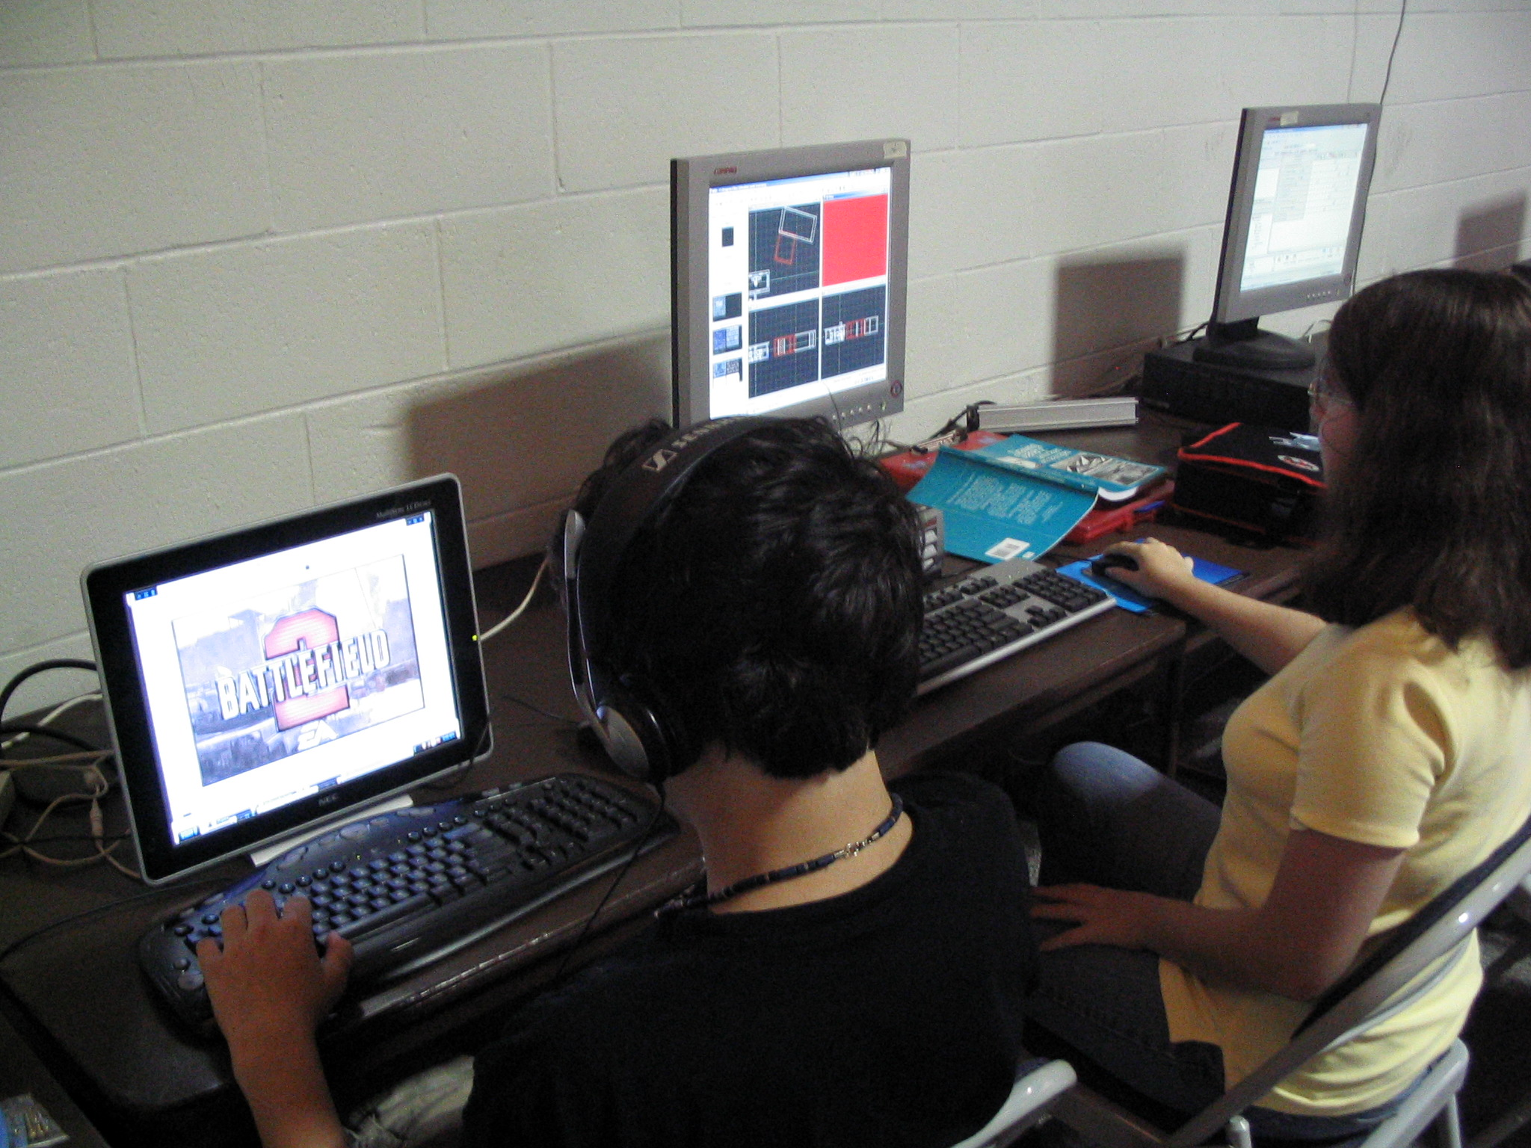

Video Game Design at Computer Camp
By: Michael Zabinski, Ph.D.
03/19/2007

Today, children are bombarded with countless ways to play, especially high-tech play through computers and video games. Over the past 25 years, games have progressed from the primitive two-paddle Pong to sophisticated, online, multi-player games such as World of Warcraft (over 7.5 million online subscribers) with complicated plots and vivid graphics that unfold over dozens of hours of play. Video game sales soared to a record $12.5 billion in 2006 and are growing at a breathtaking pace - in part, due to the phenomenal technologies of the Xbox, Playstation and Wii. These new technologies appeal to children, young adults and adults and have fundamentally changed the way that they play. The increasing prevalence and prominence of these games have caught the attention of researchers because it turns out that children's play can encourage and improve their ability to learn; games can be harnessed to promote learning.
Games Promote Learning. A crucial ingredient to effective education is motivation - that is, motivating the student to be curious and to want to absorb new information. Games certainly provide this motivation. What may be surprising, however, is that games also serve to sharpen mental acuity and promote learning. Games require and encourage focus, discipline, measured action, considered reaction, assimilation of external conditions, analytical reasoning, and strategic planning. Games improve memory and retention. Games require the setting of goals, and games usually provide encouragement and reinforcement as goals are achieved, helping to build self esteem. All of these attributes are ingredients to effective learning. Furthermore, computer and other video games have become so sophisticated that they often magnify the learning that occurs during play. And children can concentrate on games far longer than they do in other learning environments, thereby extending the learning experience.
From Playing Games to Designing Them. As children grow, their interest in games matures and sometimes evolves into a desire to create their own games. Game design offers an entirely new set of challenges, and, consequently, a new set of opportunities for learning. However, game design is not an easily self-taught science, and many children and young adults often look to their schools for help in designing their own games. Unfortunately, very few teachers understand games well enough to teach game design. In fact, game design is rarely part of an elementary or secondary school curriculum.
Computer Camps to the Rescue. At National Computer Camp (www.nccamp.com ) held annually at Universities in Connecticut, Georgia, New York and Ohio, instruction is offered in 2D and 3D game design (using 2D Multimedia Fusion by www.clickteam.com, 2D Stagecast Creator by www.Stagecast.com and 3D Game Studio by www.3dgamestudio.com). Most campers arrive at camp as experienced game players, and at camp they look for an opportunity to design their own games. They come with an active imagination and a desire to transform their ideas into an actual game.
Their imagination is the seed of their motivation, and, as they design their own game, the campers learn about geometric modeling, rendering, collision detection, character creation, plot development, storytelling, animation and graphical design. They learn to create action, adventure, and stories. They learn to work independently, and they also learn to collaborate with others. They even begin to learn about software engineering. Campers bring their ideas to life as they add sequences of challenges, music, and interactivity. Campers think creatively and logically while designing imaginative games that explore the power of 2D and 3D game design software. Game design and game playing create opportunities for leadership, competition, team work and collaboration. But most importantly, game design fosters an imaginative spirit that can spark a whole new world of learning.
Michael Zabinski, Ph.D. is the Executive Director of National Computer Camp. Visit www.nccamp.com

